**12.Arduino UNO platform-------IR_control**

1. **Preparation**

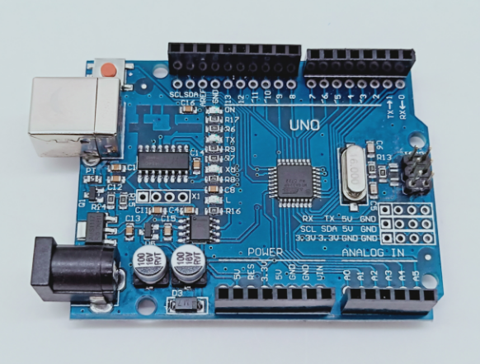

1-1 Arduino UNO board

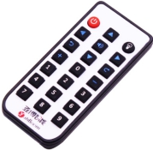 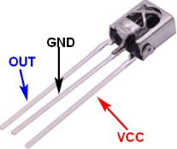

1-2 infrared remote control 1-3 infrared receiver

**2)Purpose of Experimental**

In this experiment, we used infrared remote communication to control the movement of the car. Mainly by receiving the infrared signal to control the car's forward, backward, left turn, right turn, stop, left-handed, right-handed, and servo control, as well as the control of the colorful lights, whistle, car acceleration, deceleration.

There are also modes 1-6: corresponding to the number keys 1-6

1: corresponding to the default infrared remote control

2: Patrol mode

3: obstacle avoidance mode

4: Colorful search (parking track)

5: Light seeking mode

6: Follow mode

**3)Principle of experimental**

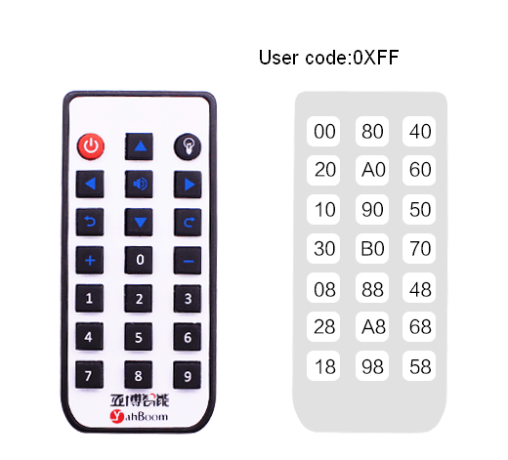

The infrared remote control receiving data is 00FFCMD (CMD inverted code); 4 data, CMD corresponds to the above code value. Then the key corresponding value is 00FF00FF.

All the received ones are as follows:

// 00FF00FF key 

// 00FF30CF + 

// 00FF708F - 

// 00FF40BF light( Switch 7 color)

// 00FFA05F beep

// 00FF807F forword

// 00FF20DF turn left

// 00FF00FF stop

// 00FF609F turn right

// 00FF906F back

// 00FF10EF turn left in place

// 00FF50AF turn right in place

// 00FFB04F 0

// 00FF08F7 1（mode1：Infrared remote control mode）

// 00FF48B7 3（mode3：Avoidance mode）

// 00FF28D7 4（mode4：7 color LED mode）

// 00FFA857 5（mode5：Seek-lighting mode）

// 00FF6897 6（mode6：following mode）

// 00FF18E7 7（servo：left）

// 00FF9867 8（servo：front）

// 00FF58A7 9（servo：right）

The function defined by each button can be customized by modifying the program.

!!!Note:

The program is divided into 2 types:

The player mode describes all the functions as above. The corresponding code folder is IR_player_mode.

The normal mode only controls the front, back, left and right, acceleration and deceleration, left and right shaking, colorful lights and whistle. the corresponding code folder is IR

**4)Experimental Steps**

4-1 About the schematic

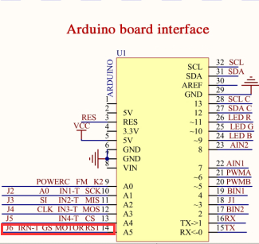

4-1 Arduino UNO interface circuit diagram 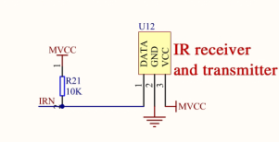

4-2 infrared receiver and transmitter

4-2 According to the circuit schematic:

IRN-----A5(Arduino UNO)

4-3 About the code

1. We need to open the code of this experiment: **IR_player_mode.ino** or **IR.ino**, click“**√**” under the menu bar to compile the code, and wait for the word "**Done compiling** " in the lower right corner, as shown in the figure below.

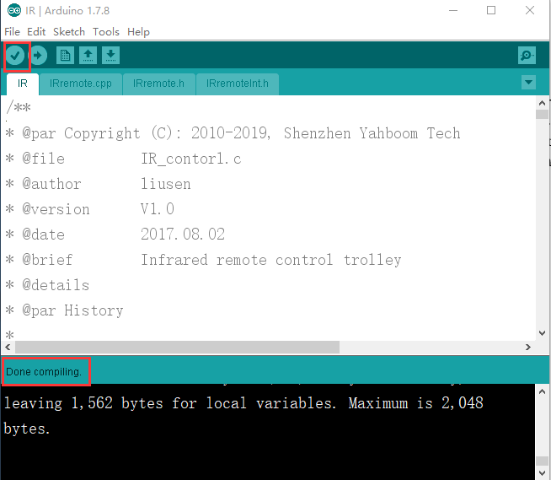

2.In the menu bar of Arduino IDE, we need to select 【Tools】---【Port】--- selecting the port that the serial number displayed by the device manager just now, as shown in the figure below.

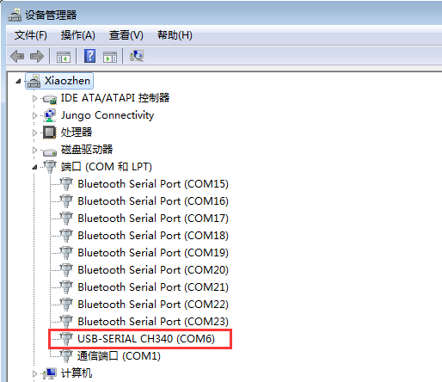

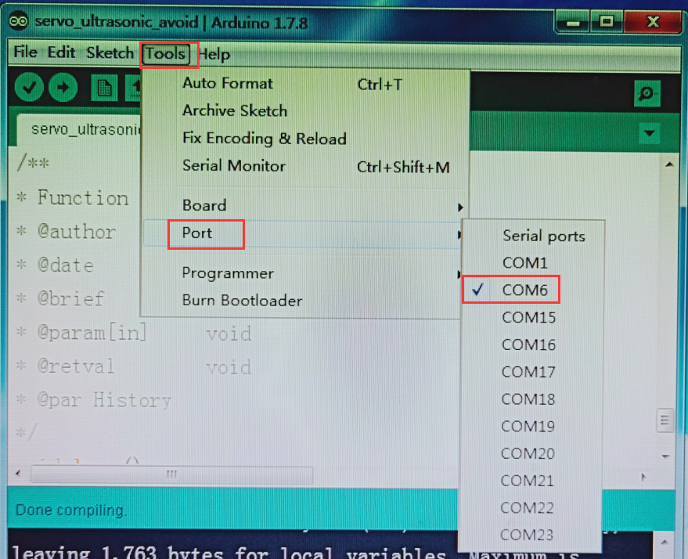

3.After the selection is completed, you need to click “**→**”under the menu bar to upload the code to the Arduino UNO board. When the word “**Done uploading**” appears in the lower left corner, the code has been successfully uploaded to the Arduino UNO board, as shown in the figure below.

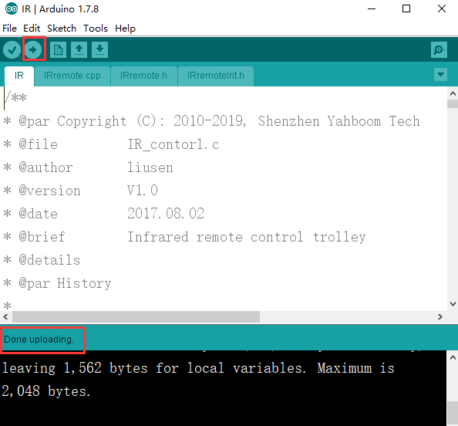

!!!Note:

When using the infrared remote controller control Arduino 4WD car, you need to unplug the grayscale module and the small fan because their pin interfaces are multiplexed.